**Find Command**

The -type f option here tells the find command to return only files.

-type f -name demo.txt: Search for a file by the name demo in the current directory and its hierarchy.

-type f -iname demo.txt: Search for a file by the name demo in the current directory and its hierarchy which includes lower and upper case or mixed case letter combination.

-type d: Search for a directory in the current directory and its hierarchy.

-type f -perm 0777: Search for files in the directory and its hierarchy where the file permission is 0777.

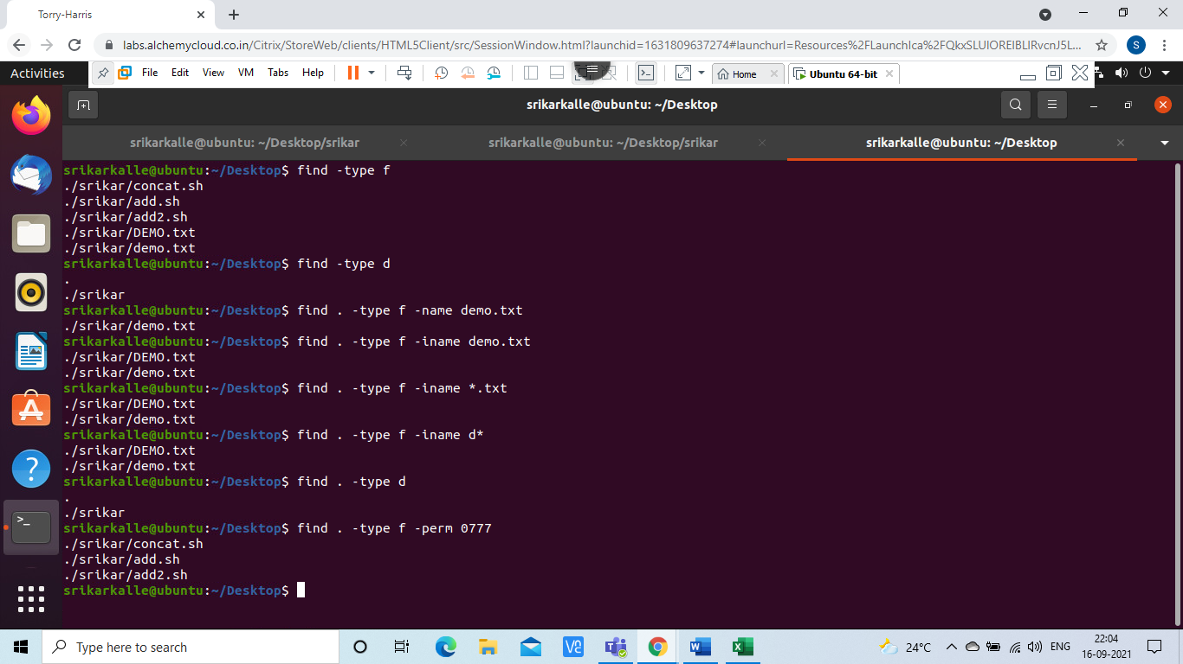

Find . -type f -perm 0777 -exec chmod 555 {} \;

It finds the file where the permission of file is 0777 and change the file permission to 555.

Find . -mtime +1

-mtime +1: It checks which all files are updated after the range of 24 hrs.

-mmtime -1: It checks which all files are updated before the range of 24 hrs.

-mmin +1: It checks which all files are updated after the range of 1 minute.

mmin -1: It checks which all files are updated below the range of 1 minute.

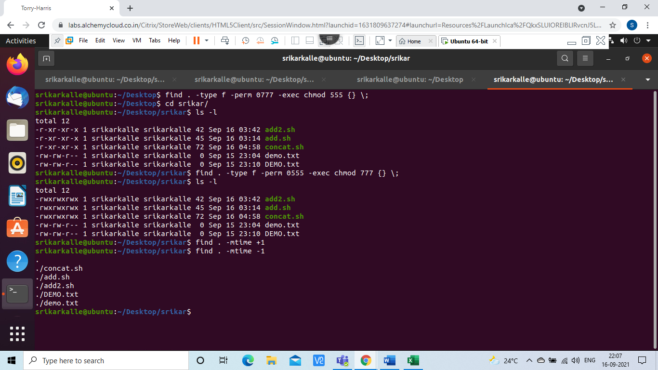

Find . -size 1M: Searching for the file where the size of the file is around 1MB

Find ./ -name sample.txt -exec rm -I {} \; :It finds for the file called sample.txt and asks permission before deleting the file.

Find ./ -name sample.txt -exec rm {} \; :It finds for the file called sample.txt and done not ask permission before deleting the file.

Find ./ -empty: It finds empty files and directories.

Find -type d: It finds directory.

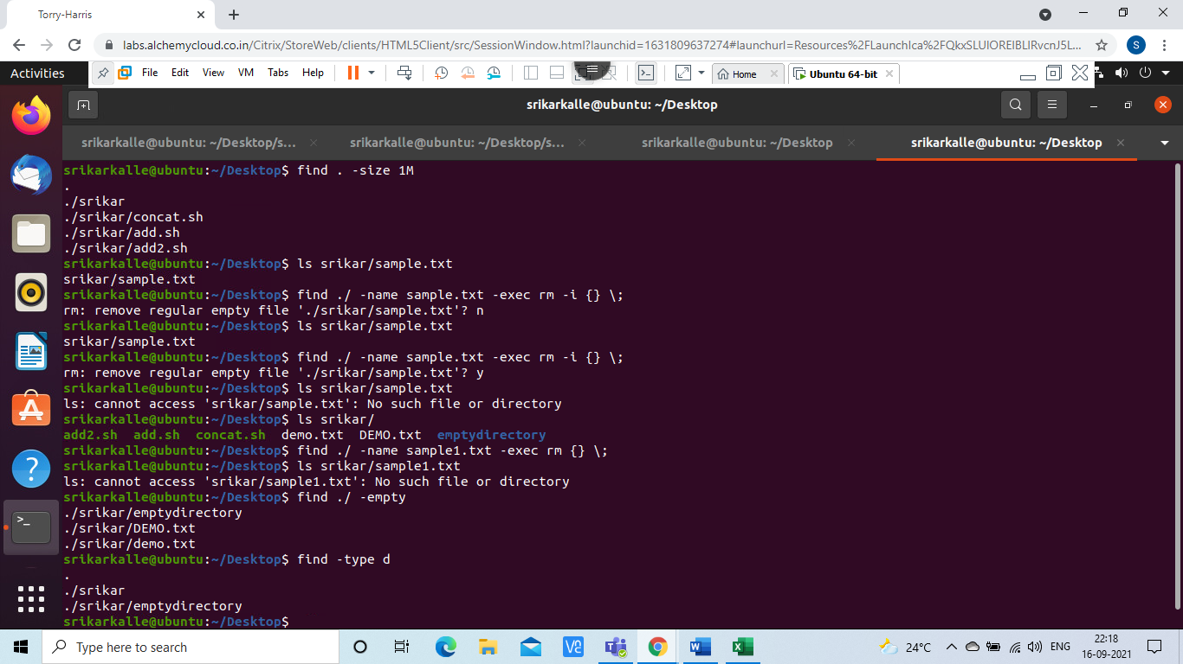

Find ./ -type f -name “*.txt” -exec grep “good” {} \;

The above command checks or finds for the file in the directory where the file ends with.txt and grep that is pattern matches the required string and display the output from the files where the required pattern exists.

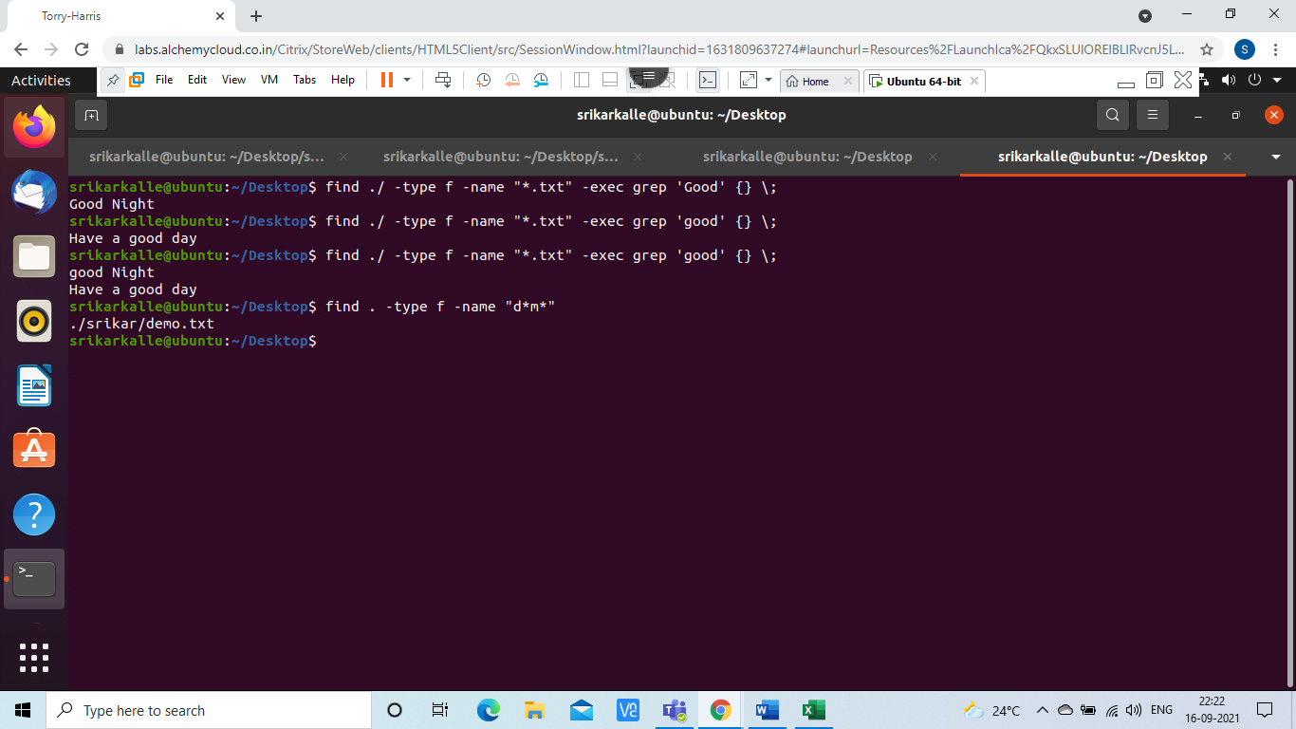

**Introduction to Bash Scripting**

Bash script to find addition of two numbers.

Code:

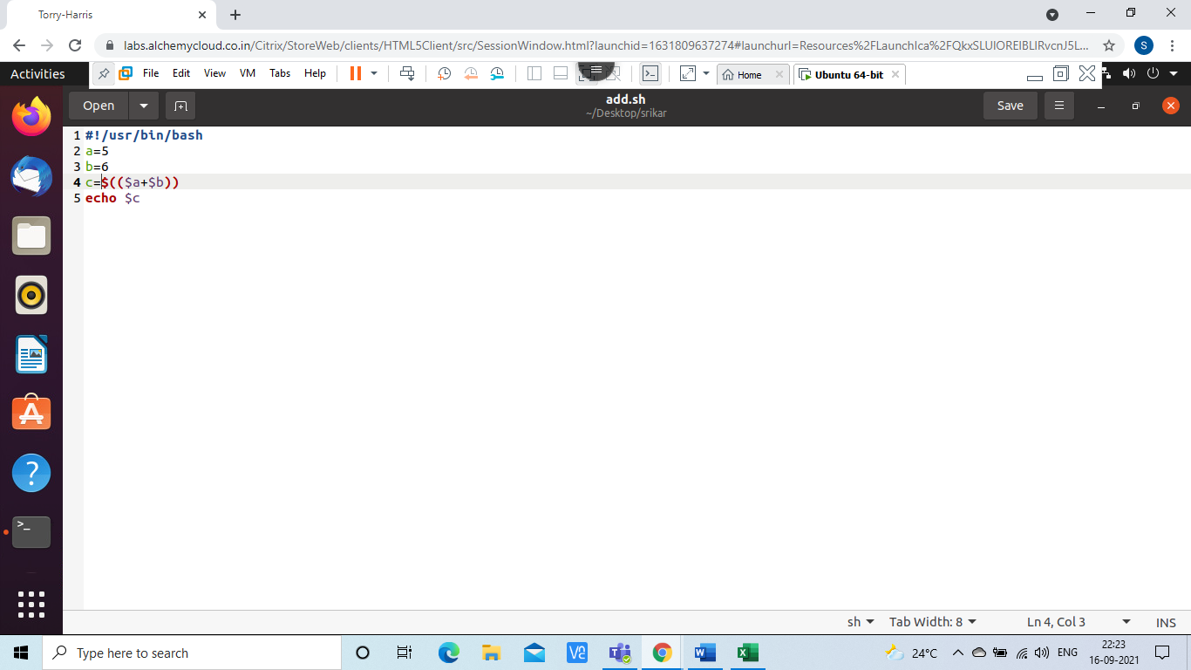

Output:

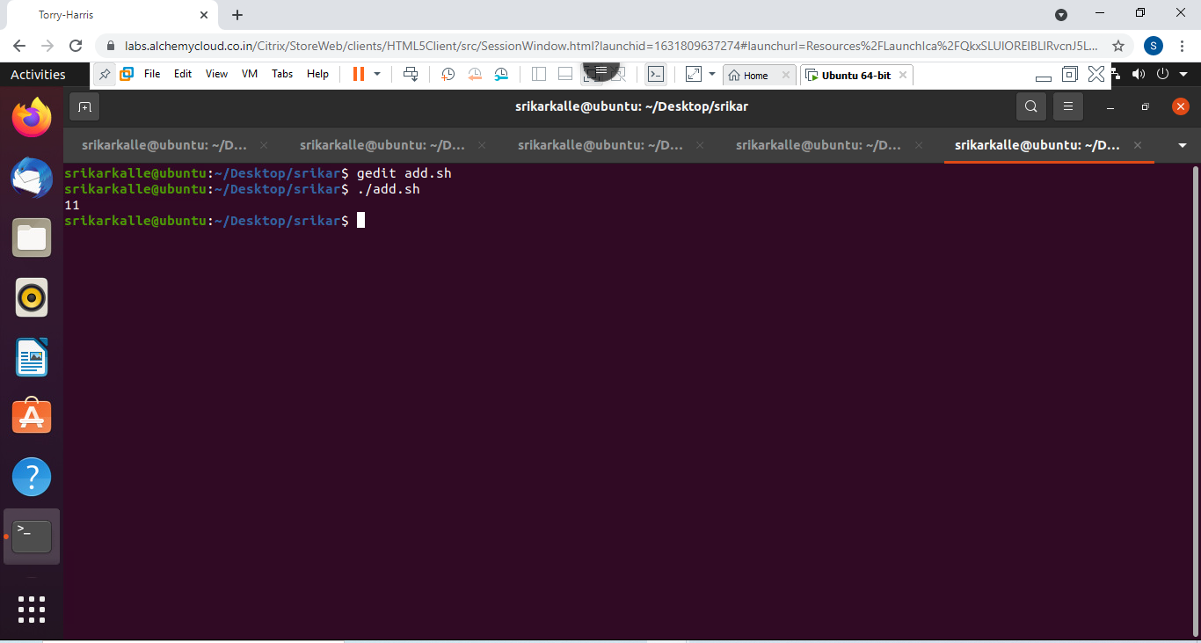

Bash script to find concatenation of strings.

Code:

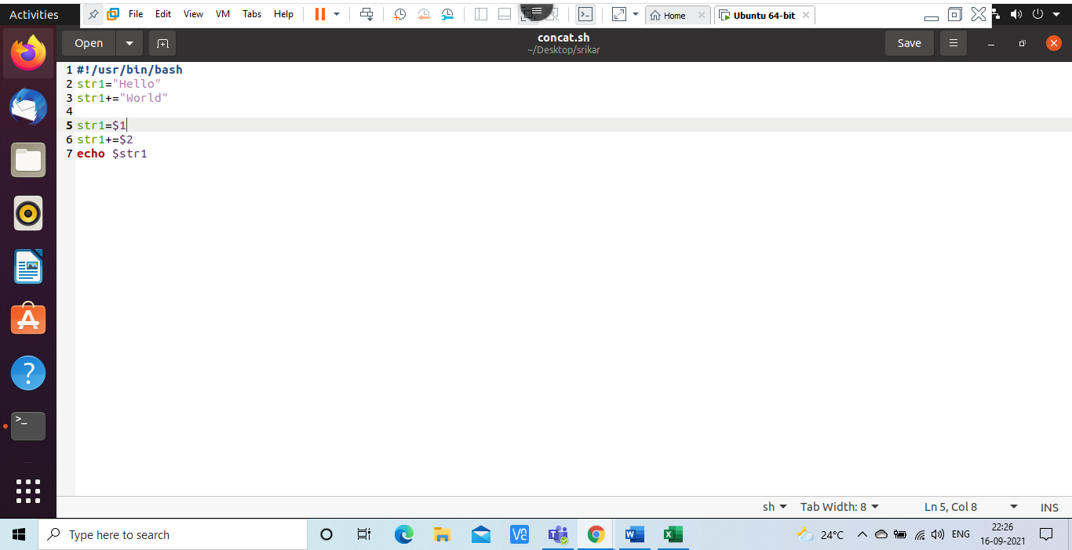

Output:

